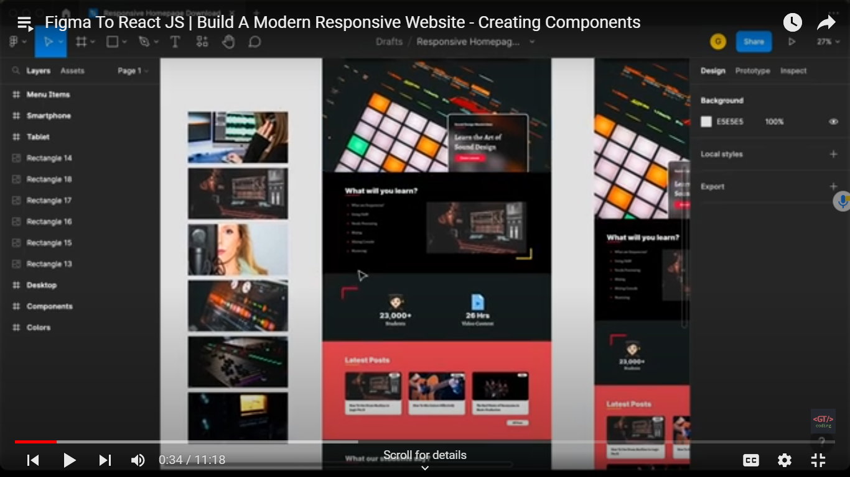

Diving whole website into different component sections - header,topic,info,blog ,testimonial footer

Create different folders for this

Src>components> header>header.jsx,header.css

Components>topic folder>topic.jsx, topic.css

Add basic code for components and add import stmt of respective css

import React from 'react';

import  "./Blog.css"

export const Blog = () => {

  return (

    <div>Blog</div>

  )

}

Import these components in app.jsx file

Then call these components in App in order of sections

<header/>

<topics/>

<info/>

<blog/>

<testimonials/>

<footer/>

Exporting all images from figma and store it in ur project folder

Copy and paste all those images into assets folder

import { Header } from './components/Header/Header'

import { Topics } from './components/Topics/Topics'

import { Info } from './components/Info/Info'

import { Blog } from './components/Blog/Blog'

import { Testimonials } from './components/Testimonials/Testimonials'

import { Footer } from './components/Footer/Footer'

Instead of importing in these many lines , u can paste all this lines inside index.js of components .

Then export{Header,Footer…..}

In app.jsx - u can do as

Import {Header,Footer,…….} from ../components/index

So compressed to one line in App.jsx.

**Componet>indexcompoennt.jsx**

import { Topics } from './Topics/Topics'

import { Header } from './Header/Header'

import { Info } from './Info/Info'

import { Blog } from './Blog/Blog'

import { Testimonials } from './Testimonials/Testimonials'

import { Footer } from './Footer/Footer'

export {Header,Footer,Topics,Info,Blog,Testimonials}

**App.jsx:**

import {Header,Footer,Testimonials,Info,Topics,Blog } from  './components/indexcomponents'

function App() {

  return (

    <>

      <Header/>

      <Topics/>

      <Info/>

      <Blog/>

      <Testimonials/>

      <Footer/>

    </>

  )

}

export default App

Lets create header compoentn

See all divisions have a fixed width . so lets define a wrapper with fixed width

import React from 'react';

import './Header.css'

export const Header = () => {

  return (

    <Header>

        <div className="wrapper">

        </div>

    </Header>

  )

}

Inside this wrapper class div, lets have whole content



Let s create inner box,

For that lets add another div.

import React from 'react';

import './Header.css'

export const Header = () => {

  return (

    <Header>

        <div className="wrapper">

            <div className=”cta”>

                <p className="course-name">Sound Design MasterClass</p>

                <h1>Learn the Art of Sound Design</h1>

                <a href="#" className='demo-btn'>Demo Lesson</a>

            </div>

        </div>

    </Header>

  )

}

Lets add some common css

Adding common colors code

**Index.css:**

From figma, got to know that overall 2 fonts are being used inter and some other.

Select these fonts from google fonts and import them.

Check the width and assign to wrapper class

Index.css:

:root{

  --dark-color:#181e1e;

  --red-color:#e63946;

  --pink-color:#ff6864;

  --yellow-color:#ffca28;

}

*,

*::after,

*::before{

  box-sizing: border-box;

}

body{

  margin:0;

  font-family: "Inter", sans-serif;

}

.wrapper{

  max-width: 1024px;

  margin: 0 auto;

}

a{

  text-decoration: none;

}

Styling header:

header{

    min-height: 100vh;

    background: url('../../assets/img1.jpg');

    background-size: cover;

    background-position: center;

}

Making cta div as position absolute , to make it display over header in right-down corner

Making wrapper relative and cta as absolute.

Header.css

header{

    min-height: 100vh;

    background: url('../../assets/img1.jpg');

    background-size: cover;

    background-position: center;

}

header .wrapper{

    position:relative;

    height: 100vh;

}

header .cta{

    position:absolute;

    bottom: 0;

    right:0;

    width:450px;

    background: rgba(0, 0, 0, 0.5);

    border-width: 4px 4px 0px 4px;

    border-style: solid;

    border-color: #ffffff;

    backdrop-filter: blur(25px);

    border-radius: 20px 20px  0px 0px;

    padding: 50px 40px;

}

header .cta .course-name{

    font-weight: 800;

    font-size: 16px;

    color:white;

}

/* //for underline for coursename - we can use after pseudo selector . giving relative position to coursename so that for after we can give position absolute */

header .cta .course-name::after{

    content:"";

    width:60px;

    height: 4px;

    background: var(--red-color);

    left:0;

    bottom:-10px;

}

header .cte h1{

    font-family: 'Courier New', Courier, monospace;

    font-weight: 700;

    font-size: 40px;

    line-height: 140%;

    color: white;

}

header .cte  .demo-btn{

    border-radius: 10px;

    background: var(--red-color);

    color: white;

    padding: 10px 32px;

    font-weight: 700;

    font-size: 16px;

}

Creating navbar:

Header.jsx:

Import navbar from ‘./navbar/navbar.jsx’

Calling navabr in header.jsx

        <div className="wrapper">

            <Navbar />

\            <div className='cta'>

                <p className="course-name">Sound Design MasterClass</p>